Handout: Meeting Set-Up
Basic Room Set-Up
Item |  | How Many Needed |  | What is there now? |  | Where to get more
Tables & chairs
Power strips
Projector & screen
Whiteboard, markers & eraser
Lectern or podium
Microphone
Laptop
Comfort
Item |  | Yes/No | Alternative Room |  | Who can fix this?
Temperature comfortable
Room in quiet location
Room has privacy
Water in room
Extras
Item |  | Yes/No/NA | Description |  | Who is in charge of this?
Name tents
Table with name tags
“Welcome” banner
Signage outside
Keepsake or logo item
Music
Folders prepared
Candy or mints on tables
Posters or visual aids
Video loop before meeting starts
Other
Other
Seating Arrangement
(Circle desired style)
Conference | U-Shape |  |  | T-Shape |  |  | Classroom
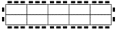 | 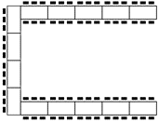 |  |  | 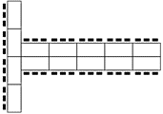 |  |  | 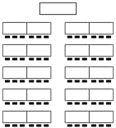
Notes:

