## Handout: Electronic Options

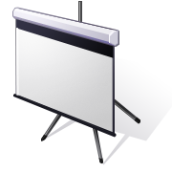

Presentation program:

[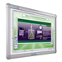](https://www.schooloutfitters.com/catalog/product_info/pfam_id/PFAM8958/products_id/PRO22501)Programs like Microsoft Power Point help to organize your materials into one file. Once the information is in the presentation program, you can make handouts that you can give to your participants as an agenda.

Electronic whiteboard:

An electronic whiteboard is an efficient way to write and record ideas all with one source. The electronic device acts like a normal whiteboard, but uses special electronic markers. This electronic device also records the items written on the board for referencing later.

Web meeting programs:

Programs similar to Microsoft Live Meeting allow you conduct your meeting via the Internet. Voice, images from your desktop, and a web cam view of the meeting room and the individual.



Video conferencing:

This dedicated line uses cameras and television screens to connect two or more remote sites into one meeting.

j0412270[1]

Telephone conferencing:

This is a dedicated telephone line where many participants call in and participate in the meeting.

Things to Consider When Using Electronics

* Is the complexity of adding the technology outweighing the potential glitches?
* Are you capable enough to handle any issues that may arise during your meeting?
* Is your audience capable of handing the technology?
* Will you have adequate support from your IT department?
* Are there any costs that you have to consider?