## Sample Sign

Please Silence all

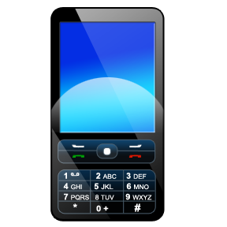

Thank You